Pets at Home, Peace at Work: The Mental Health Boost You Didn’t Expect

“Feeling drained at work even after a good night’s sleep?” Perhaps the solution is wagging its tail at home. Today, having a pet at home not only keeps you company but also supports your mental well-being.
A study by Mars Petcare and Calm found that, 92 % of Indian pet parents reduce screen time, 93 % take more frequent work breaks, and 79 % report better sleep, outperforming global averages (Tiwari, 2025). The study also noted that pets help their family to feel more relaxed and calmer when they rest near them. These statistics highlight the vital role of pets in our lives; they reduce anxiety and stress, ease overthinking, boost morale, strengthen social bonds, and enhance productivity. Whether it’s a cat curled up beside your laptop or a dog nudging you to take a break, pets bring rhythm, joy, and calm that nourish not just our hearts but also our workdays.
From reducing stress to improving focus, pets can play a quiet yet powerful role in employee wellness. Through our workshops and strategic support, we help organizations foster healthier, more engaged workplaces.
📧 Let’s create healthier, more resilient workplaces together.
✨ Reach us at workplacewellbeingbyywp@gmail.com ✨
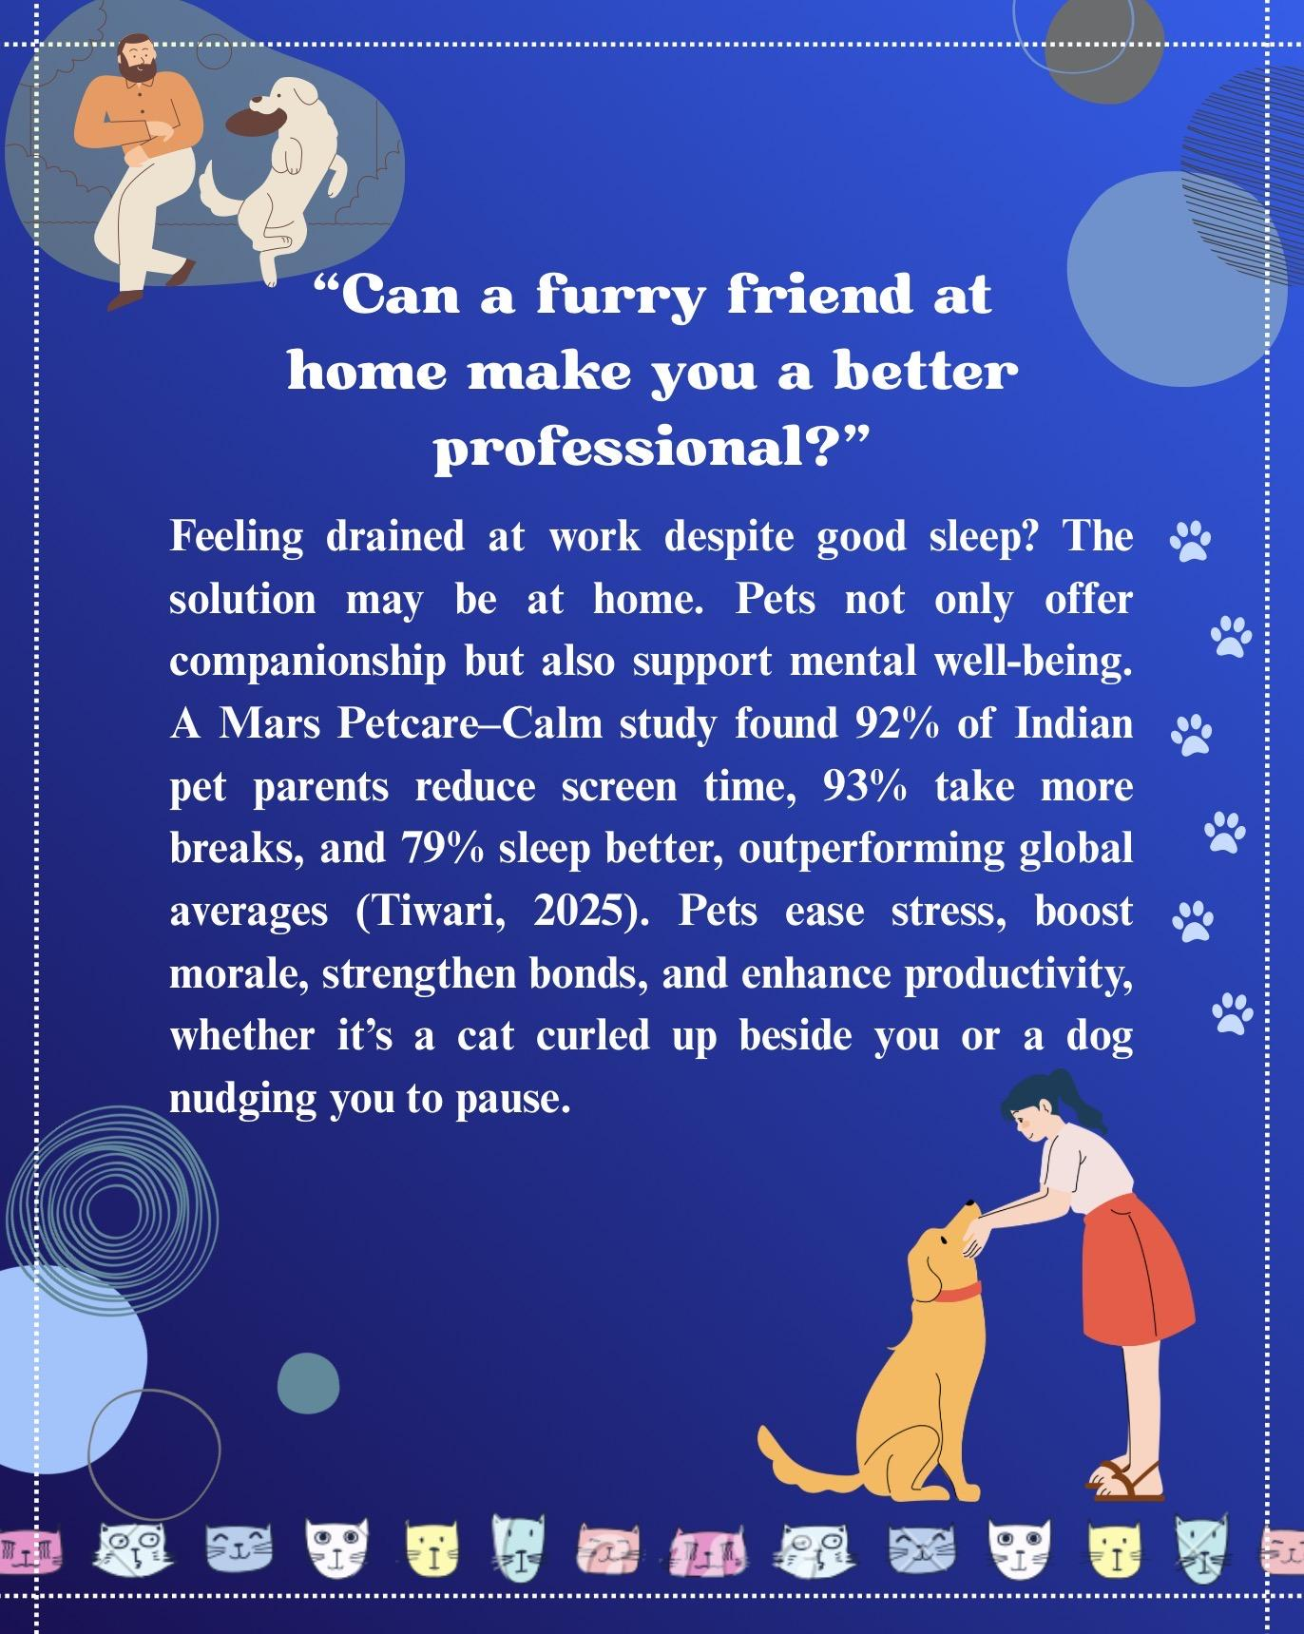

References
Tiwari, P. (2025, June 10). Want better mental health? Get a pet - Times of India. The Times of India. Retrieved July 27, 2025, from https://timesofindia.indiatimes.com/business/india-business/want-better-mental-health-get-a-pet/articleshow/121756058.cms

